**Build Box From Scratch**

**Prerequisites:**

Primary partition has been reformatted.

**Steps:**

|  |  |  |  |  |
| --- | --- | --- | --- | --- |
| **#** | **Item** | | **File** | **Notes** |
| 1 | OS Windows 2003 Enterprise Edition | | N/A | From CD. Name Server: PHEONIX |
| 2 | Desktop Setup | | N/A | For Administrator |
| 3 | IIS | | From Control Panel > Add Remove Programs |  |
| 4 | LAN Port | | D:\DDrive\Software\0_Microsoft\0_OS\Marvell\32\ Setup.exe  Update Driver to:  D:\DDrive\Software\0_Microsoft\0_OS\Marvell_31122009 | As Administrator |
| 5 | Drivers | | Click and Go | From CD |
| 6 | ATI Device Driver | | D:\DDrive\Software\ATI\6-2_xp-2k_dd_30152.exe | Will fix refresh rate |
| 7 | MICROSOFT DirectX 9.0c | | D:\DDrive\Software\ATI\dxwebsetup.exe |  |
| 8 | Modem-Router | | Check that it is working on http://<Default Gateway> | Use ipconfig /all |
| 9 | MS Updates | |  | From Microsoft Update |
| 10 | TextPad | | D:\DDrive\Software\TextPad\txpeng531.exe | 3.5.15 NOT 3.6 as doesn’t currently work with Hudson Selenium Grid plugin. |
| 11 | FireFox | |  | Import bookmarks.html and install add-ons |
| 12 | IE 8 | | D:\DDrive\Software\0_Microsoft\1_Applications\IE8-WindowsServer2003-x86-ENU.exe | Don’t enable SmartScreen Filter. Import bookmarks from Firefox |
| 13 | MS Office | | D:\DDrive\Software\0_Microsoft\1_Applications\Office 2007  D:\DDrive\Software\0_Microsoft\1_Applications\Visio 2007 Pro  D:\DDrive\Software\0_Microsoft\1_Applications\MSProject2007\2007 Pro |  |
| 14 | MS Updates | |  | From Internet |
| 14A | Users | | Create fcdglory user | Add to PowerUsers group to enable ability to shutdown |
| **Log off Administrator and log on as andrewg** | | | | |
| 15 | | Repeat Steps 2, 10 and 11 for andrewg |  |  |
| 16 | | .NET 3.5 | D:\DDrive\Software\0_Microsoft\dotNet\dotnetfx35.exe |  |
| 17 | | MS Updates |  | Pick up .NET 3.5 SP1 |
| 18 | | SilverLight 2.0 | D:\DDrive\Software\0_Microsoft\Silverlight.2.0.exe |  |
| 19 | | Adobe Reader | D:\DDrive\Software\Adobe Reader 9 Installer\Setup.exe |  |
| 20 | | SQL Server 2008 | From CD (SQL Server Enterprise) | Name Instance: PHEONIX  Configure Main instance Data and Log files to E:\SQL.  Configure SSAS files to D:\SQL Server\SSAS\. |
| 21 | | SQL Server 2008 SP1 | D:\DDrive\Software\0_Microsoft\1_Applications\MSSQL2K8\SQLServer2008SP1-KB968369-x86-ENU.exe |  |
| 21a | | SQL Server Edition Upgrade | If installed Developer edition first. Can upgrade edition by running “Edition Upgrade” from the SS2008 Enterprise CD. |  |
| 22 | | MS Updates |  | From Internet |
| 23 | | Restore Databases and SSIS Job |  | See steps below  NEED TO DELETE AspNetServicesUser, eStoreUser and eStoreAdminUser and create the Logins as they may be missing after you Attached the database. |
| 24 | | Zippers | D:\DDrive\Software\Zippers | WINRAR Only |
| 25 | | NUnit | D:\DDrive\Software\xUnitFrameworks\NUnit-2.5.9.10348.msi |  |
| 25A | | NLog | D:\DDrive\Software\NLog\NLog-1.0-Refresh-setup.exe |  |
| 26 | | Java | D:\DDrive\Software\Java\JDK\jdk-6u23-windows-i586.exe | Set JAVA_HOME and Path=%JAVA_HOME%/bin |
| 28 | | SVN | D:\DDrive\Software\SubVersion\VisualSVN-Server-2.1.5.msi |  |
| 30 | | Tortoise | D:\DDrive\Software\SubVersion\TortoiseSVN-1.6.12.20536-win32-svn-1.6.15.msi |  |
| 31 | | Nero | D:\DDrive\Software\Nero\Nero-6.6.1.4_no_yt.exe THEN D:\DDrive\Software\Nero\InCD-4.3.23.2.exe | Get licence key from Nero.v6.6.0.16.Keymaker-CORE.ZIP |
| 32 | | Selenium-Grid | D:\DDrive\Software\Selenium\selenium-grid-1.0.4-bin.zip | Extract to C:\Program Files |
| 33 | | Hudson | 1. Delete old hudson windows service from command line (sc –delete hudson) 2. Download hudson.exe and copy to c:\temp. 3. Run java –jar hudson.war from command line of c:\temp 4. Backup current <hudson directory> 5. Install Hudson as a Windows Service (specify previous <hudsonHome> directory as home directory) 6. Test it. 7. Delete backup of <hudsonHome> directory 8. Change hudson Windows service to run as andrewg.   See Hudson Config.doc |  |
| 34 | | Visual Studio 2008 | From CD | Custom install everything except SQL Server 2005 Express |
| 35 | | Visual Studio 2008 SP1 | D:\DDrive\Software\0_Microsoft\1_Applications\Visual Studio 2008 Service Pack 1\Extract\SPInstaller.exe | Runs for a long time….just let it run to completion. |
| 35A | | HotFix | D:\DDrive\Software\0_Microsoft\1_Applications\VS2008HotFixFiles\ | Run this to fix bugs |
| 35B | | Clone Detective | Run D:\DDrive\Software\0_Microsoft\CloneDetective_VS2008_Setup.zip |  |
| 35C | | AnkhSvn | Run D:\DDrive\Software\SubVersion\AnkhSvn-2.1.10019.14.msi |  |
| 36 | | MS Updates |  | From Internet |
| 37 | | Visual Tools for Applications | Should be installed as part of Visual Studio 2008 SP1 |  |
| 38 | | SQL Cache Invalidation | Follow the Steps in section 1.1 and 1.2 of SQL Server Setup Steps.doc |  |
| 39 | | SQL Server eStore Logins | Follow the Steps in section 1.3 of SQL Server Setup Steps.doc |  |
| 39A | | Parent Path | eStoreAdmin Parent Paths should be turned off. Not needed | WebSite Properties > Home Directory > Configuration…>Options > Enable Parent Paths checkbox should be off. |
| 40 | | FXCop | D:\DDrive\Software\0_Microsoft\1_Applications\FxCopSetup.exe |  |
| 41 | | Unlocker | D:\DDrive\Software\unlocker\unlocker1.9.0.exe | UNCHECK eBay Shortcuts |
| 42 | | Ant | D:\DDrive\Software\Apache\apache-ant-1.8.1-bin.zip | Extract to C:\Program Files\Apache Software Foundation.  ANT_HOME and Path=% ANT_HOME %/bin |
| 43 | | Maven | Check website for latest version OR use:  D:\DDrive\Software\Apache\apache-maven-2.2.1-bin.zip  Follow installation and setup instructions here:  <http://maven.apache.org/users/index.html> | Extract to C:\Program Files\Apache Software Foundation |
| 44 | | MSBuild | Install D:\DDrive\Software\0_Microsoft\dotNet\SDC Tasks - Release 2.1.3155.0 to d:\BuildTools | Only need:   1. Microsoft.Sdc.BizTalkOM.dll 2. Microsoft.Sdc.Common.tasks 3. Microsoft.Sdc.Tasks.BizTalk.dll 4. Microsoft.Sdc.Tasks.dll |
| 45 | | MSBuild | Run MSI in D:\DDrive\Software\0_Microsoft\MSBuild Extension Pack.zip | Will install to C:\Program Files\MSBuild |
| 46 | | Wix | Run D:\DDrive\Software\Wix\Wix3.0.5419.0-x86.msi | Install Wix Binaries |
| 46A | | Tarma InstallMate 7 | Run D:\DDrive\Software\Tarma InstallMate 7\tin7.exe |  |
| 47 | | WixSharp | Copy D:\DDrive\Software\Wix\WixSharp.0.1.31 to C:\Program Files\ |  |
| 48 | | WixSharp | Run C:\Program Files\WixSharp.0.1.31\InstallUpdated.cmd |  |
| 49 | | WixSharp | Update Path Environment variable to add %WIXSHARP_WIXDIR% and %WIXSHARP_DIR% |  |
| 50 | | EazFuscator | Install D:\DDrive\Software\0_Microsoft\Eazfuscator.NET 2.7 Setup.msi |  |
| 51 | | NConstruct | Install D:\DDrive\Software\NConstruct\NcbSetupLite.msi |  |
| SECOND LAST | | Fix IIS Issue | <http://support.microsoft.com/kb/2009746>  <http://blogs.msdn.com/jaskis/archive/2009/12/09/after-installing-kb-973917-the-iis-6-0-application-pools-cannot-start-up.aspx> | To fix issue with KB890830 and IIS remove KB973917 |
| LAST | | Win2003 SP2 | D:\DDrive\Software\0_Microsoft\0_OS\Windows2003\WindowsServer2003-KB914961-SP2-x86-ENU.exe | Reinstall Win2003 SP2 |

**FireFox Addons**

|  |  |  |
| --- | --- | --- |
| **#** | **Item** | **File** |
| 1 | IFoxFork Graphite | From Internet |
| 2 | FireBug | From Internet |
| 3 | FlagFox | From Internet |
| 4 | FoxClocks | From Internet |
| 5 | IE Tab 2 | From Internet |
| 6 | McAfee SiteAdvisor | D:\DDrive\Software\FireFox\ saSetup3.0.1.163.exe |
| 7 | Morning Coffee | From Internet |
| 8 | Web Developer | From Internet |
| 9 | Download StatusBar | From Internet |
| 10 | FireSpider | From Internet |
| 11 | iMacros | Property Settings:  Folder Macros: D:\DDrive\Stuff\iMacros\Macros  Folder Datasources:: D:\DDrive\Stuff\iMacros\Datasources  Folder Downloads: D:\downloads\iMacros  Logs Events: D:\DDrive\Stuff\iMacros\Logs  External Editor: C:\Program Files\TextPad 5 |
| 12 | Mini Meter | IINET UserName and AccountPassword |

**SQL Server 2008**

*Users*

|  |  |
| --- | --- |
| **#** | **User** |
| 1 | SSAgent |
| 2 | SSDBEngine |
| 3 | SSAS |
| 4 | SSRS |
| 5 | SSFullText |

*Restore Databases*

|  |  |  |  |
| --- | --- | --- | --- |
| **#** | **Item** | **File** | **Notes** |
| 1a | Create empty eStore Database AND Restore eStore DB Backup | D:\eStoreBackups\SQLBACKUPS\eStore\eStore_backup_yyyy_mm_dd_hhmmss_nnnnnnn.bak OR  D:\SQLServer\Backup\eStore_backup_yyyy_mm_dd_hhmmss_nnnnnnn.bak | With Overwrite option |
| 1b | …OR  Reattach existing database MDF file at E:\SQL\ |  |  |
| 2a | Create empty AspNetServicesDB database AND Restore AspNetServicesDB Backup | D:\SQLServer\Backup\AspNetServicesDB_backup_yyyy_mm_dd_hhmmss_nnnnnnn.bak | With Overwrite option |
| 4 | …OR  Reattach existing database MDF file at E:\SQL\ |  |  |

**How to definitively fix Update Exchange Rate SSIS package**

|  |  |  |  |
| --- | --- | --- | --- |
| 1 | Open UpdateExchangeRates SLN in Business Intelligence Development Studio | D:\Visual Studio 2008\SSIS\UpdateExchangeRate\UpdateExchangeRate.dtsx |  |
| 2 | Delete connection object and create a new OLE DB connection. Enter sa details for connection |  |  |
| 3 | Open WSCall task and re-add Web Reference to “http://www.webservicex.net/CurrencyConvertor.asmx” |  | Need to resolve references to  Currency.  Save.  Recompile. |
|  | Run Job inside BI Studio to ensure it works |  |  |
|  | Save SLN |  |  |
|  | Log onto Integration Services | D:\Visual Studio 2008\SSIS\UpdateExchangeRate\UpdateExchangeRate.dtsx | Select MSDB folder. Right Click and select Import Package. Select source as File system.  Find UpdateExchangeRate.dtsx file in Bin direction on filesystem.  Set Package Protection Level to “Rely on server storage and roles for access control”.  After importing UpdateExchangeRates should be sitting under MSDB. |
|  | Start Agent and create job |  | Job to call UpdateExchangeRates Integration Services package.  Under General Tab, make PHEONIX\andrewg SQLServer user (who is part of the sysadmin role) the owner of the job.  Go to Security > Logins > eStoreAdminUser > Properties > User Mapping. Select msdb. Make default schema dbo and select SQLAgentOperator role. Click ok. |
|  | Create Schedule for job |  | Every Day every 6 hours from 12:00:00AM to 11:59:59PM |
| 11 | Start job to test it |  | Should finish successfully. |
| 12 | Check Currency Table |  | Last Update datetime should be result of step 11. |

**Check version of SQL Server (should say Enterprise Edition | 10.0.4000.0) | SP2 | | 10.00.4000:**

SELECT

SERVERPROPERTY('Edition') AS 'Edition',

SERVERPROPERTY('ProductVersion') AS 'ProductVersion',

SERVERPROPERTY('ProductLevel') AS 'ProductLevel',

SERVERPROPERTY('ResourceLastUpdateDateTime') AS 'ResourceLastUpdateDateTime',

SERVERPROPERTY('ResourceVersion') AS 'ResourceVersion'

GO

http://www.mssqltips.com/tipimages2/1824_image001.png

**Jenkins**

**Getting Create WIX Files jobs to work**

1. Set Jenkins Windows Service to run as andrewg user
2. Restart Windows service
3. To svn.exe to store windows authentication credentials you may need to run the command from Application.bat (batch file run by Jenkins in the job) for each of the jobs from the command line so you can respond to any prompts store the credentials.

**KEY APPLICATION SCREENSHOTS**

**Visual Studio 2008**

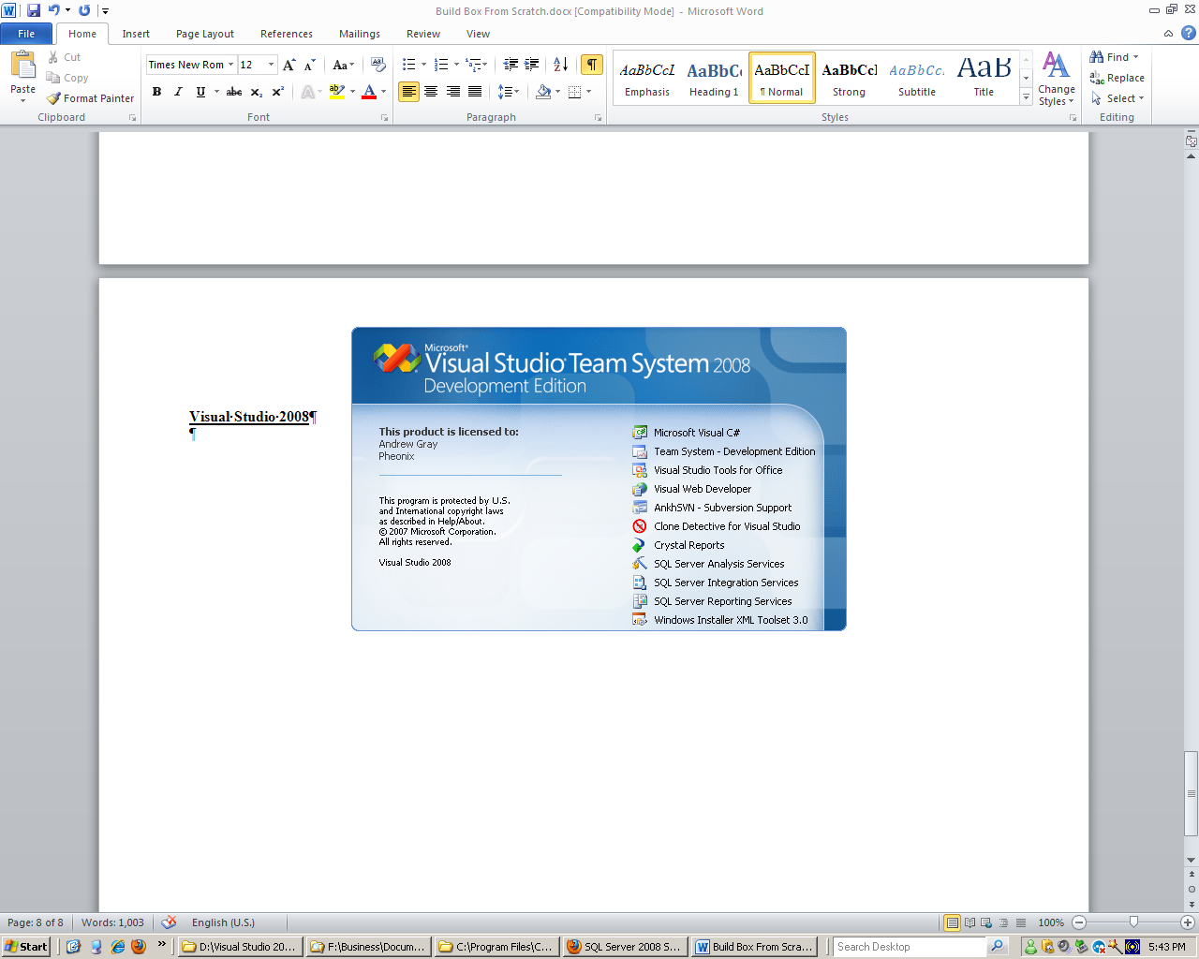

**Quick Start Menu**

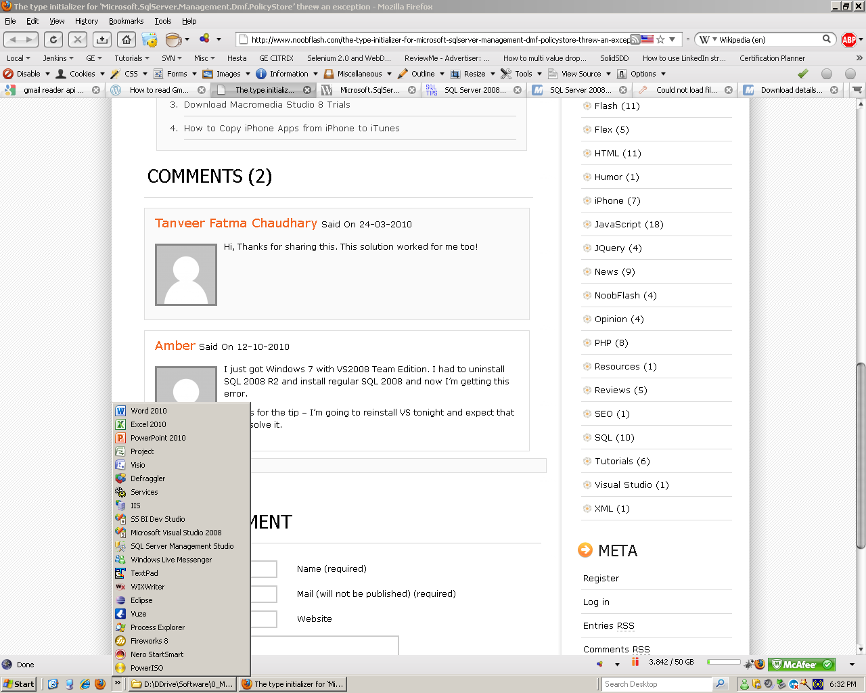

**FIREFOX 3.5.19 PLUGINS**

